Resources Available in our Rooms

Our rooms are well equipped with computers for use with:

- Ancestry
- Find My Past (including 1921 census)
- The Genealogist
- My Heritage
- Roots Ireland
- FamilySearch (we are an Affiliated Library)
We also have:

- Microfiche
- CDs
- A Library of Reference books & books for loan
- Laminator
- Book Binding
- Pedigree and Family Charts

Volunteers are always on hand to assist with research & advice.

Volunteers are available to help with your research and enquiries

Closed Public Holidays

Charges

Internet Access $1.00 per ½ hour
CD use $1.00 per hour
Microfiche reader $1.00 per hour
Workshops
- Members $8.00
- Non Members $10.00
DNA SIG Gold coin donation

When and Where We Meet

Meetings
Cnr Third Ave & Jack Ireland Park Rd, Mandurah

General:
2nd Saturday of each month at 1.30pm except December & January usually with a guest speaker.

DNA Special Interest Group:
3rd Tuesday of each month at 10.00am except December & January

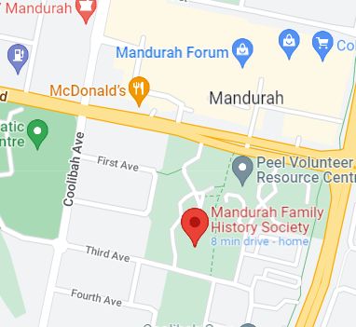

Research Rooms opening hours

Monday, Wednesday, Friday
9.30am – 3.30pm
Saturday 9.30am – 1.00pm
Volunteers are available to help with your research and enquiries

Closed Public Holidays

Membership Fees
1 April – 31 March

Single $37.00 plus joining fee $12.00 = $49.00
Joint $57.00 plus joining fee $24.00 = $81.00

Visitor’s fee per day for research $8.00 plus charges

Updated Jan 2024
Mandurah Family History Society Inc

Genealogical Research

Affiliated with FamilyHistoryWA

Affiliated with FamilySearch

Research Worldwide for your ancestors

What Genealogy means:

- An account of the descent of a person, family or group through an ancestral line
- An investigation of pedigree

Our Address

Corner of Third Ave & John Ireland Park Rd,
Mandurah, Western Australia 6210

PO Box 1091,
Mandurah, Western Australia 6210
This Photo by Unknown Author is licensed under CC BY-NC
Phone: 9586 9760

Email: mfhs@westnet.net.au

Website: mfhs.org.au
This Photo by Unknown Author is licensed under CC BY
Facebook: www.facebook.com/mfhs6210

Why Should You Join MFHS?

Mandurah Family History Society is a group of amateur enthusiasts whose aim is to help members to get the most out of their family history. Whilst you do not need to belong to a group, membership provides access to extensive resources and the assistance of other like-minded people

Is Family History for Me?

Most people join because they have a curiosity about their family, a need to prove their ancestral roots, or to investigate family stories.

If you have ever had a twinge of curiosity, why not dip your toes in the water now.

- It can deepen a connection to a family’s past, present and future
- It develops a better understanding of your background and how your family’s role in society has evolved
- It develops skills in reasoning and creativity. Learn to be a detective!
- Do you have a convict in your family
- DNA can assist in tracing your biological family tree

To discover a little more about your family’s history, join the friendly and supportive group at Mandurah Family History Society.

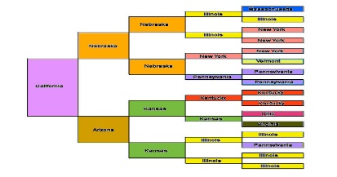
This Photo by Unknown Author is licensed under CC BY-NC-ND

Guest Speakers

We have a variety of speakers at our Saturday meetings with many varied topics that may include but not limited to:

- Australia
- Convicts
- DNA
- England & Scotland
- Europe
- Military Records
- Individual stories from members’ research
- Ireland
- Local
- Migration
- Shipping Records

Volunteers

Our volunteers have a variety of interests covering many countries and subjects and are always keen to assist with your research.

FamilySearch

More records are being digitized on a daily basis by FamilySearch. As an affiliated library MFHS is able to access records that are not available to those researching from home.
It is well worth a visit to see what extra records are accessible and how to obtain them. Records can be printed or downloaded to a thumb drive.

Other databases

MFHS has full subscriptions to Ancestry, My Heritage, Find My Past, The Genealogist and Roots Ireland. These are for the use of members saving them the cost of subscribing themselves, which can prove quite costly.

Committee

MFHS is run by a committee which is voted in at the Annual General Meeting each year in May. All committee members are volunteers.

The committee manages the day to day running of the society along with the help of volunteers who assist with rosters, monthly newsletters, IT maintenance, afternoon teas and general shopping.

DNA Special Interest Group

This group discusses all things related to DNA and is open to all members with an interest in tracing their ancestral line using DNA as well as conventional methods.
Discussions are held on the latest findings or programs as well as trouble shooting for members to try to knock down some brick walls.
Non members are also invited to attend for 2 visits before joining as an introduction.

Welcome

MFHS welcomes visitors to come along and see what is involved in tracing your family and volunteers are always happy to answer any questions.

